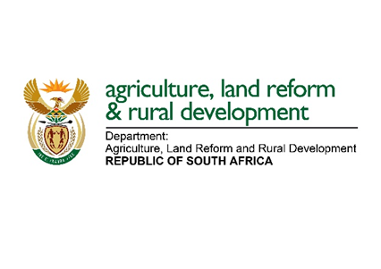
Media Statement 29 April 2020

MINISTER DIDIZA ANNOUNCES THE WAY FORWARD UPON CLOSURE OF COVID-19 INTERVENTION APPLICATION PROCESS

The Minister of Agriculture, Land Reform and Rural Development, Ms Thoko Didiza, MP is pleased to announce that by the closing date of applications for the COVID-19 intervention, 42 444 application forms were received against the number of 34 612 forms distributed. It must be noted that the difference in the number of forms distributed is the result of additional means of distribution being used, such as social media platforms; downloads from the website; farmers sharing forms among themselves; and forms distributed by famer organisations and social partners.

The Minister is pleased to announce that the overall rate of returned forms is 123%. Given the short space of time due to the urgency of this intervention, the Minister is satisfied with the response by small-scale and communal farmers.
“It is pleasing also to note that eight provinces achieved a 100% return rate. These are Northern Cape, Mpumalanga, Limpopo, KwaZulu-Natal, Gauteng, Eastern Cape, North West and Free State,” remarked Minister Didiza.

From 23 April 2020, various districts commenced with the evaluation process with the intention to complete all processes by 8 May 2020, after which all successful applicants/farmers will receive their vouchers to collect inputs from various retailers, wholesalers and “Koparasies”.

“I would like to thank provincial MECs, Mayors and officials who have worked tirelessly to amplify the message after the announcement of this intervention and we are fully aware that owing to lockdown challenges many famers could not apply,” said Minister Didiza.

Minister Didiza wishes to remind farmers that inputs will be capped at R50 000 per farmer and the commodities to be supported are as follows:
- Poultry: Day-old chicks, point of lay chickens, feed, medication and sawdust;
- Vegetables: Seedlings, fertilisers, pesticides, herbicides and soil correction.
- Fruits: Final spraying programmes for fruits that are ready for harvest.
- Other livestock: Feed and medication.
- Winter field crops: Soil correction, fertilisers, seeds, herbicides and pesticides.

The Minister urges all those farmers who could not submit their applications on time due to various reasons or challenges not to despair, as other departmental programmes that will be announced soon for the 2020/21 financial year will try to reach as many farmers as possible in all provinces.

Ends
For media enquiries, please contact the Media Liaison Officer, Mr Reggie Ngcobo, on 0828832458.
Issued by the Department of Agriculture, Land Reform and Rural Development

